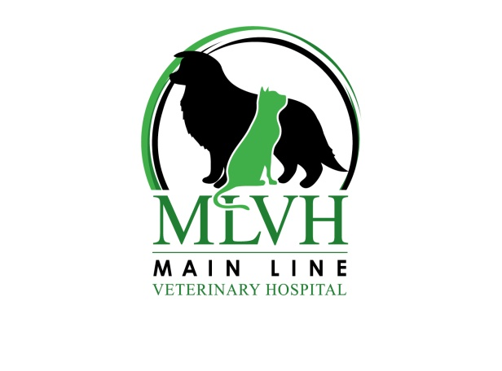

Our office is in the Malvern/Frazer area at 245 Lancaster Avenue (Directly across from McKenzie’s Restaurant on Route 30)
Phone: (610) 695 0860
Fax: (610) 695 0862
Email: email@mainlinevetmalvern.com

$1 EXAM FOR NEW CLIENTS ONLY – BY APPOINTMENT ONLY
(PRINT OUT AND BRING WITH YOU.)

Please arrive 5-10 minutes before your appointment time so we can have time to go through your paperwork.
Also, remember to bring any previous records/vaccine certificates with you.
If you don’t have records, we would be happy to contact your previous veterinarian so they can fax us information before your office visit, although they may require you to provide written permission for this.

